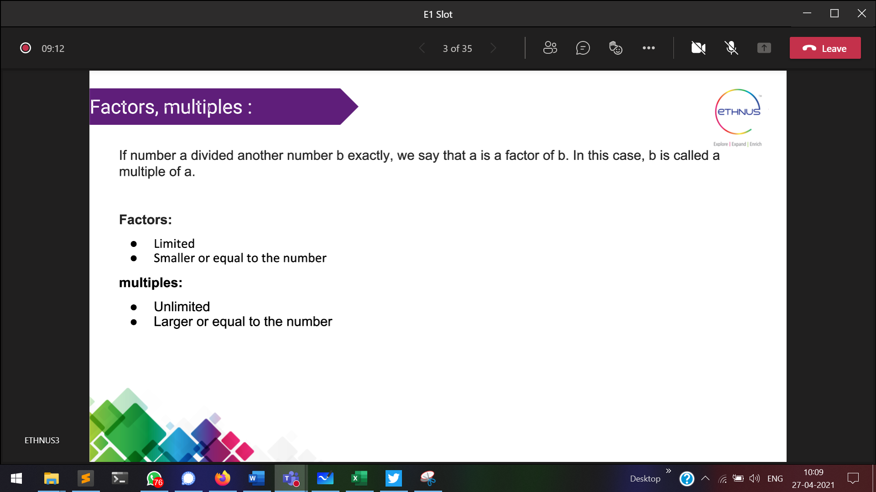

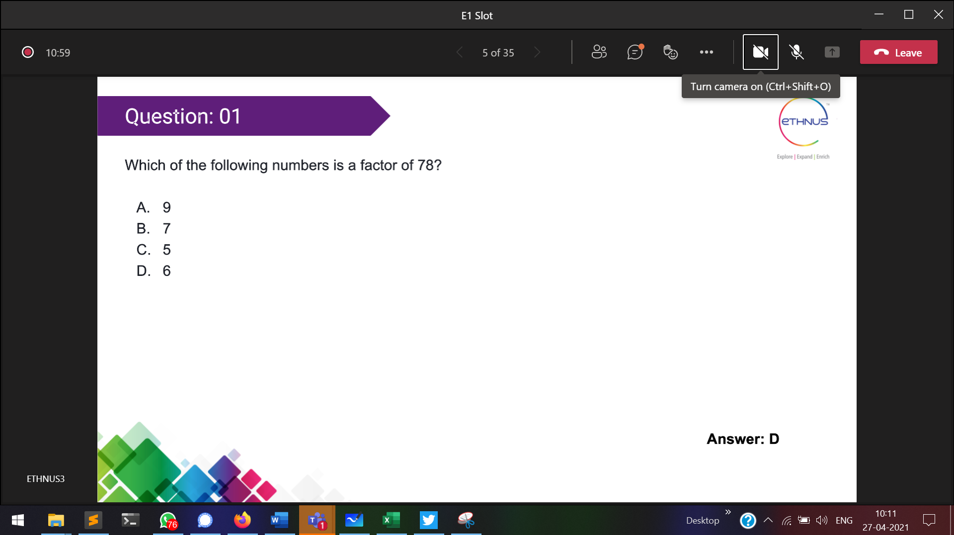

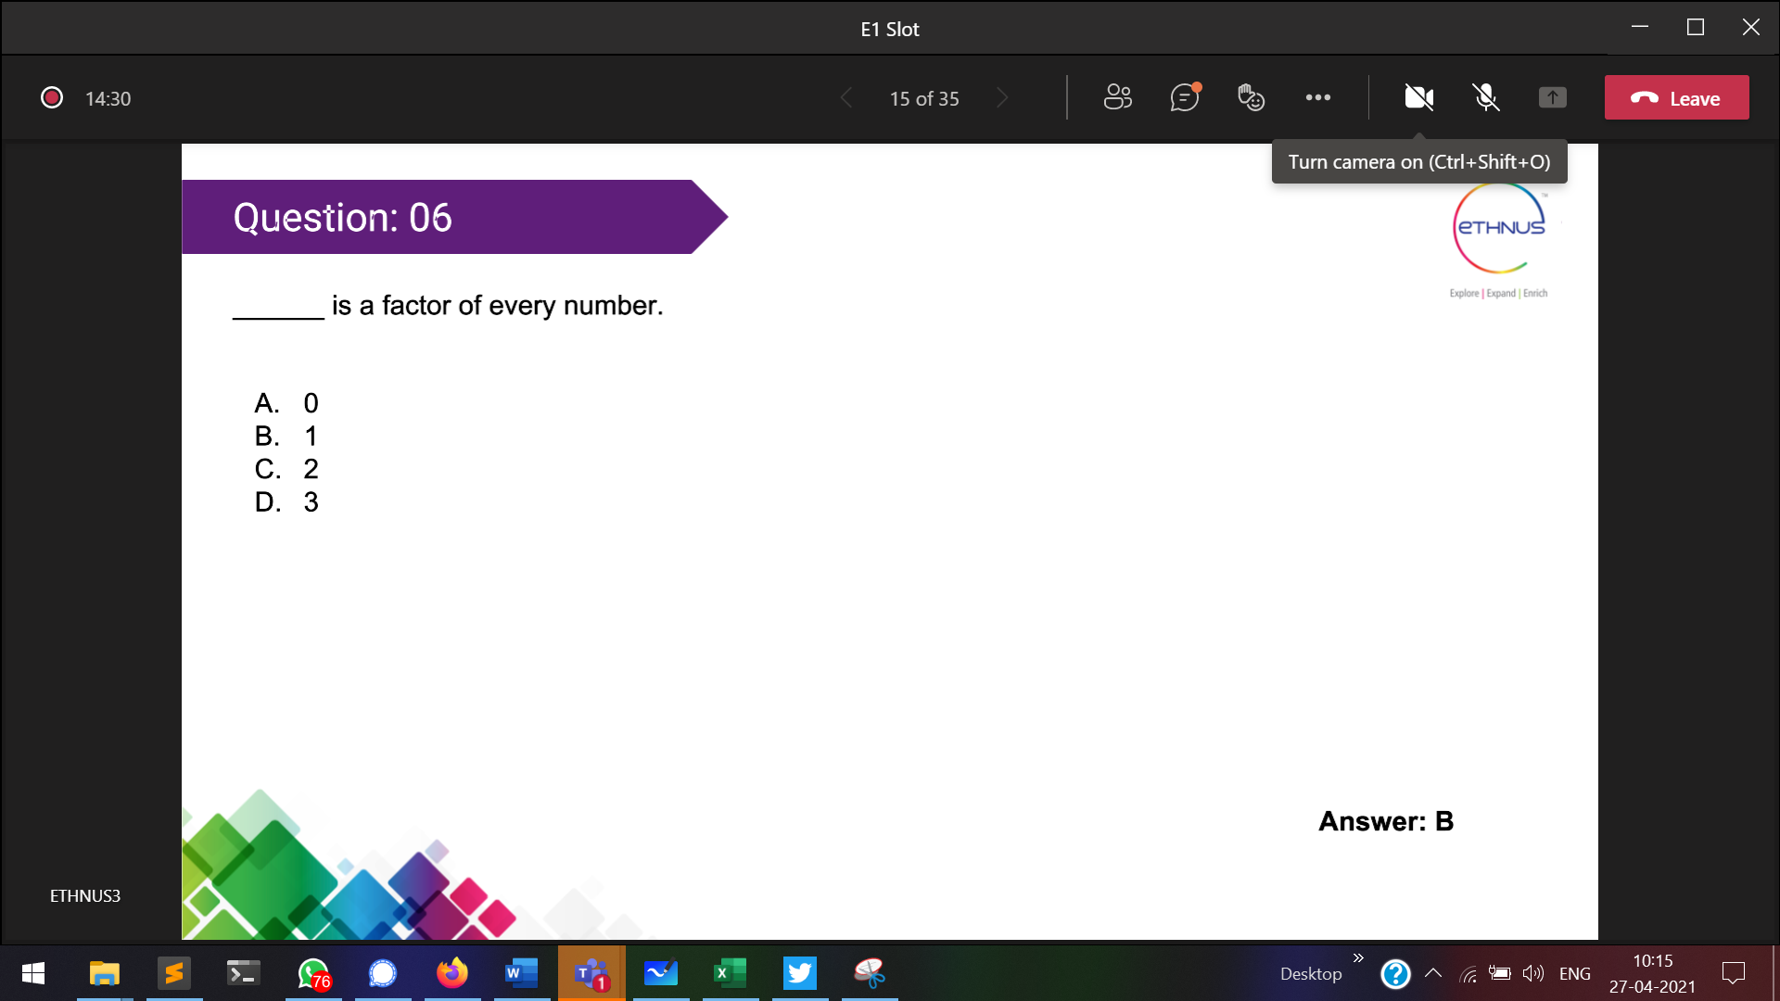

Mulitiple of every number 🡪0  
fac

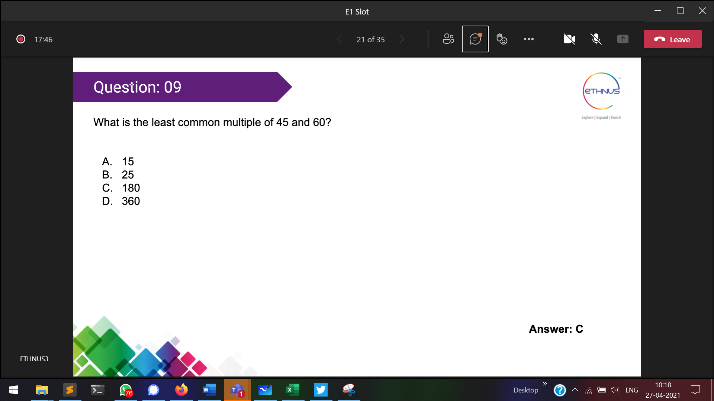

Multiple of a number cannot be less than that number

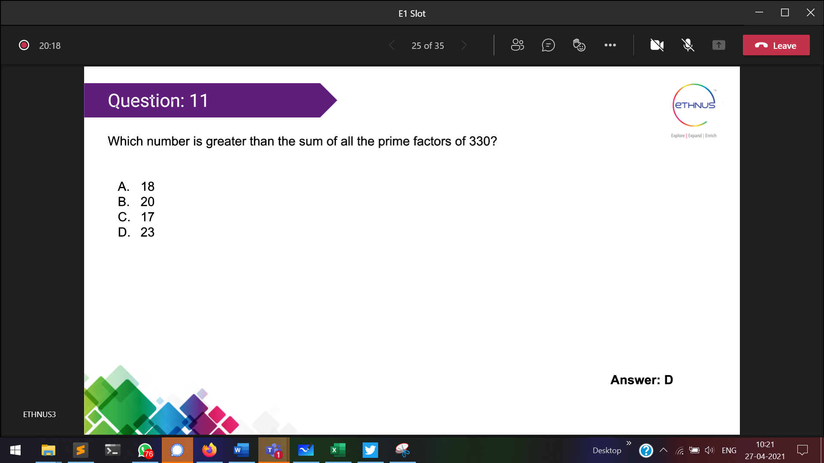

21>23

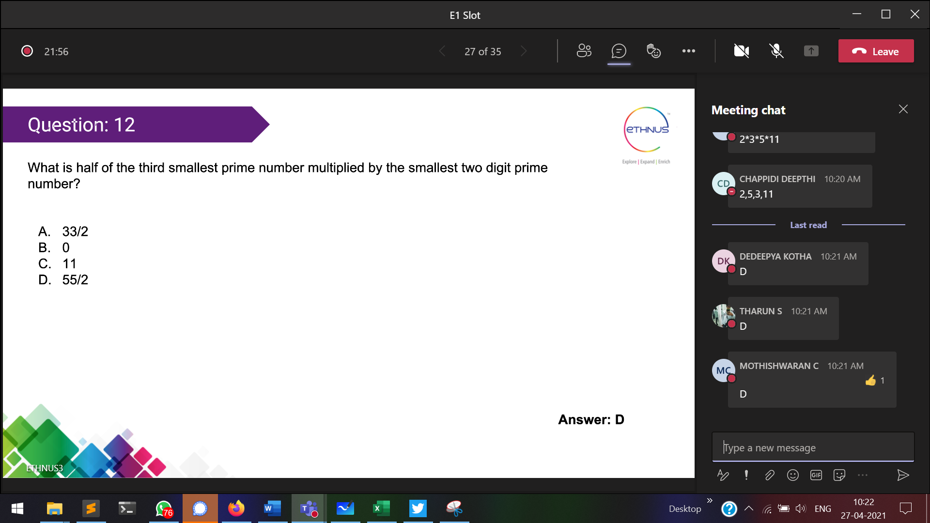

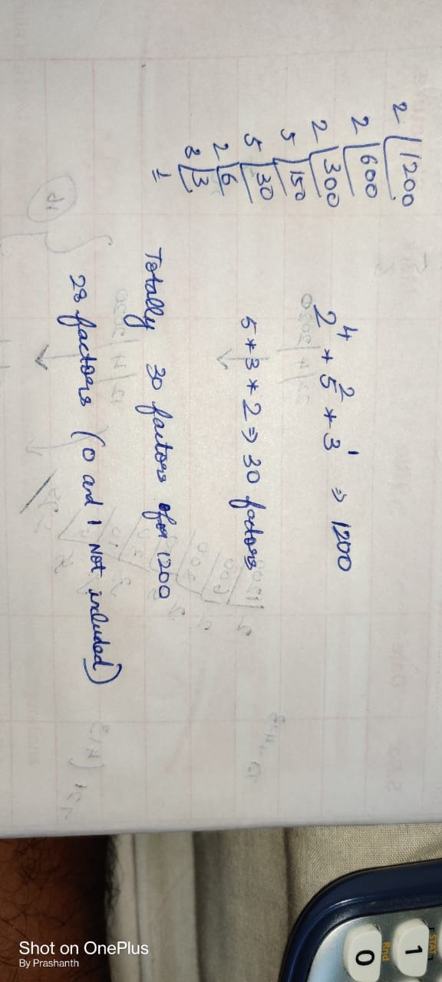

Present tense 🡪 Subject + Verb + s/es + Object

Present continuous tense 🡪 Subject + is/am/are + Verb + ing + object

Present Perfect tense 🡪 Subject + has(singular)/have(plural) + Verb + Object

Present Perfect Continuous tense 🡪 S + has been(singular)/have been(plural) + Verb + ing + Object

Simple past 🡪 S + V + O

Past continuous tense 🡪 S + was + V + ing + O

Past perfect tense 🡪S + had + V + O

S + had been + V + ing + O

Simple future tense 🡪 S + will/shall + V + O

Future continuous tense 🡪 S+ will be/shall be + ing + V + O

Future perfect tense 🡪 S + will have/shall have + V + O

Future perfect continuous tense 🡪 S + will have been + V + ing + O

Parts of Speech

Noun

Pronoun

Adverb 🡪 describes the verb (ends with ly)

Verb

Adjective 🡪 describes the noun

Preposition

Conjunction

interjection

famous argument 🡪 “because cannot be used at beginning of statement because because is a conjuction”

Verb

1. Base verb
2. Simple present tense
3. Present participle
4. Simple past tense
5. Past participle

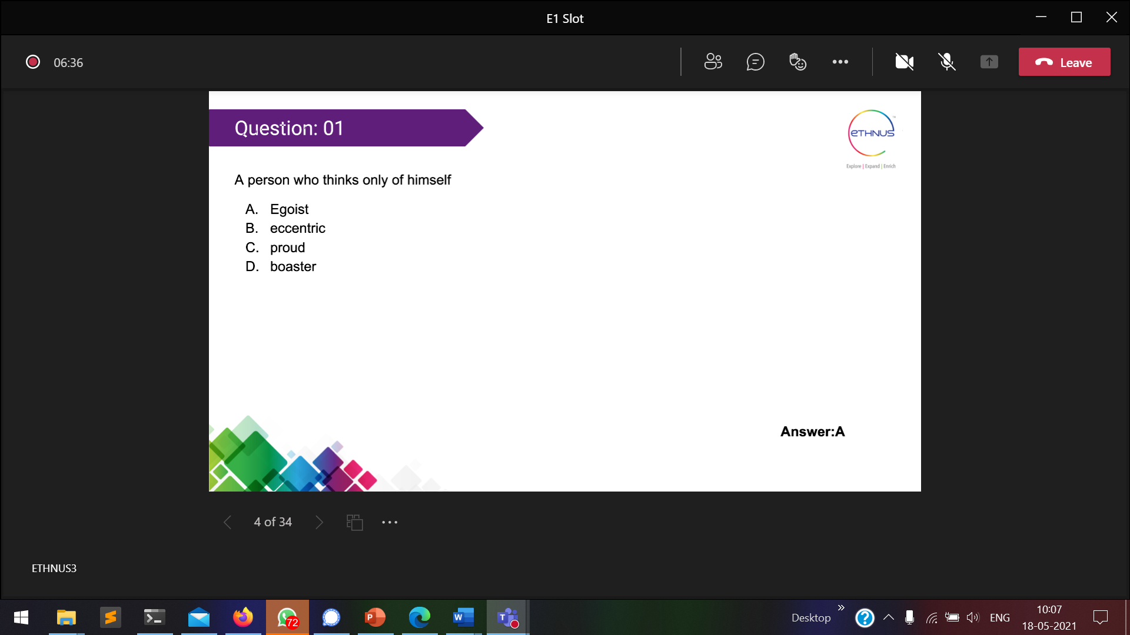

Egoist 🡪   
Eccentric 🡪   
Boaster 🡪 more talkative

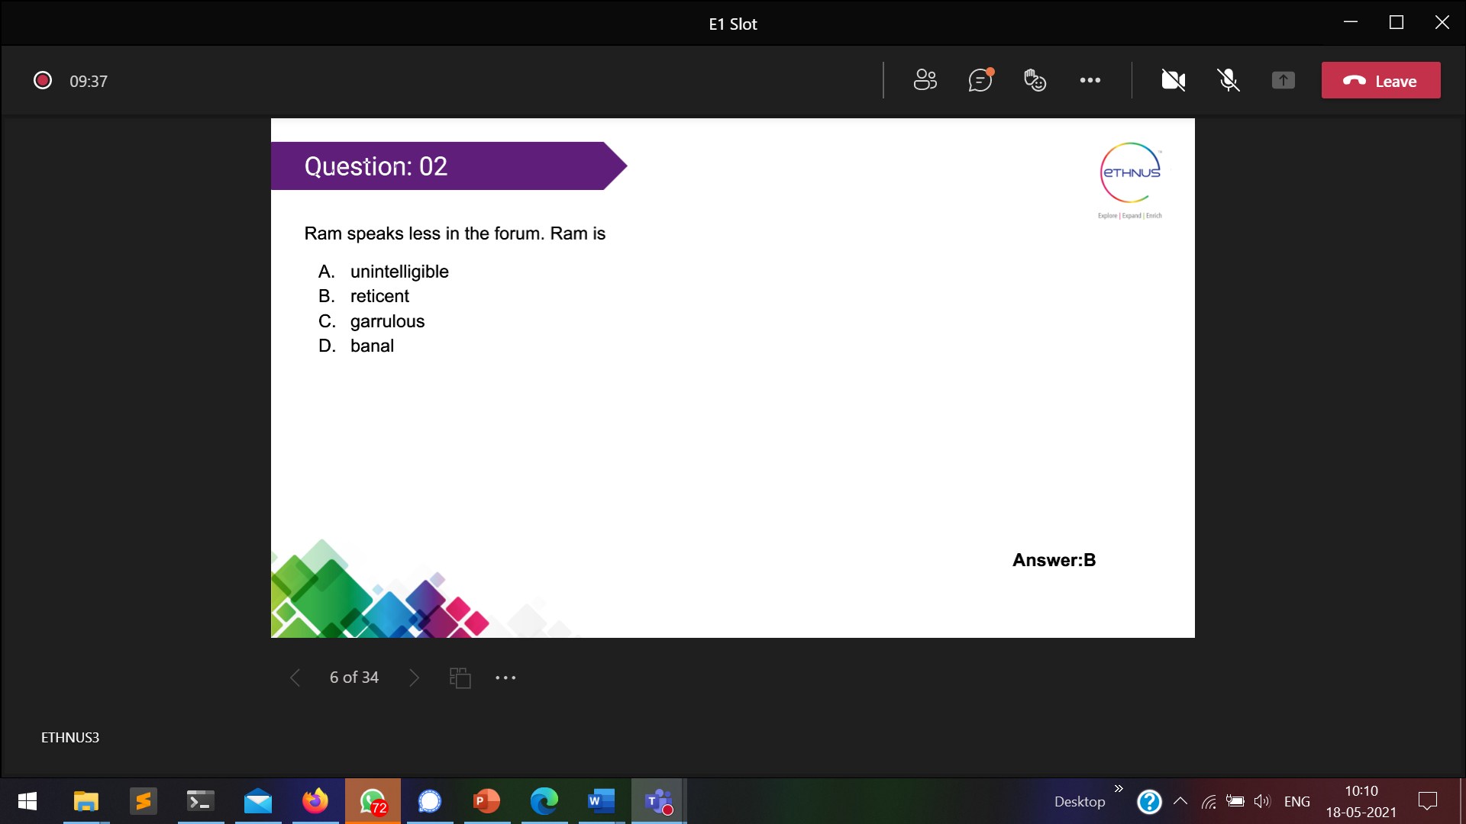

Unintelligible 🡪

unintelligible 🡪 புரியாத

Reticent 🡪 not able to communicate

* Garrulous 🡪 Who talks more
* Banal 🡪 Who is not more obvious (hides their originality

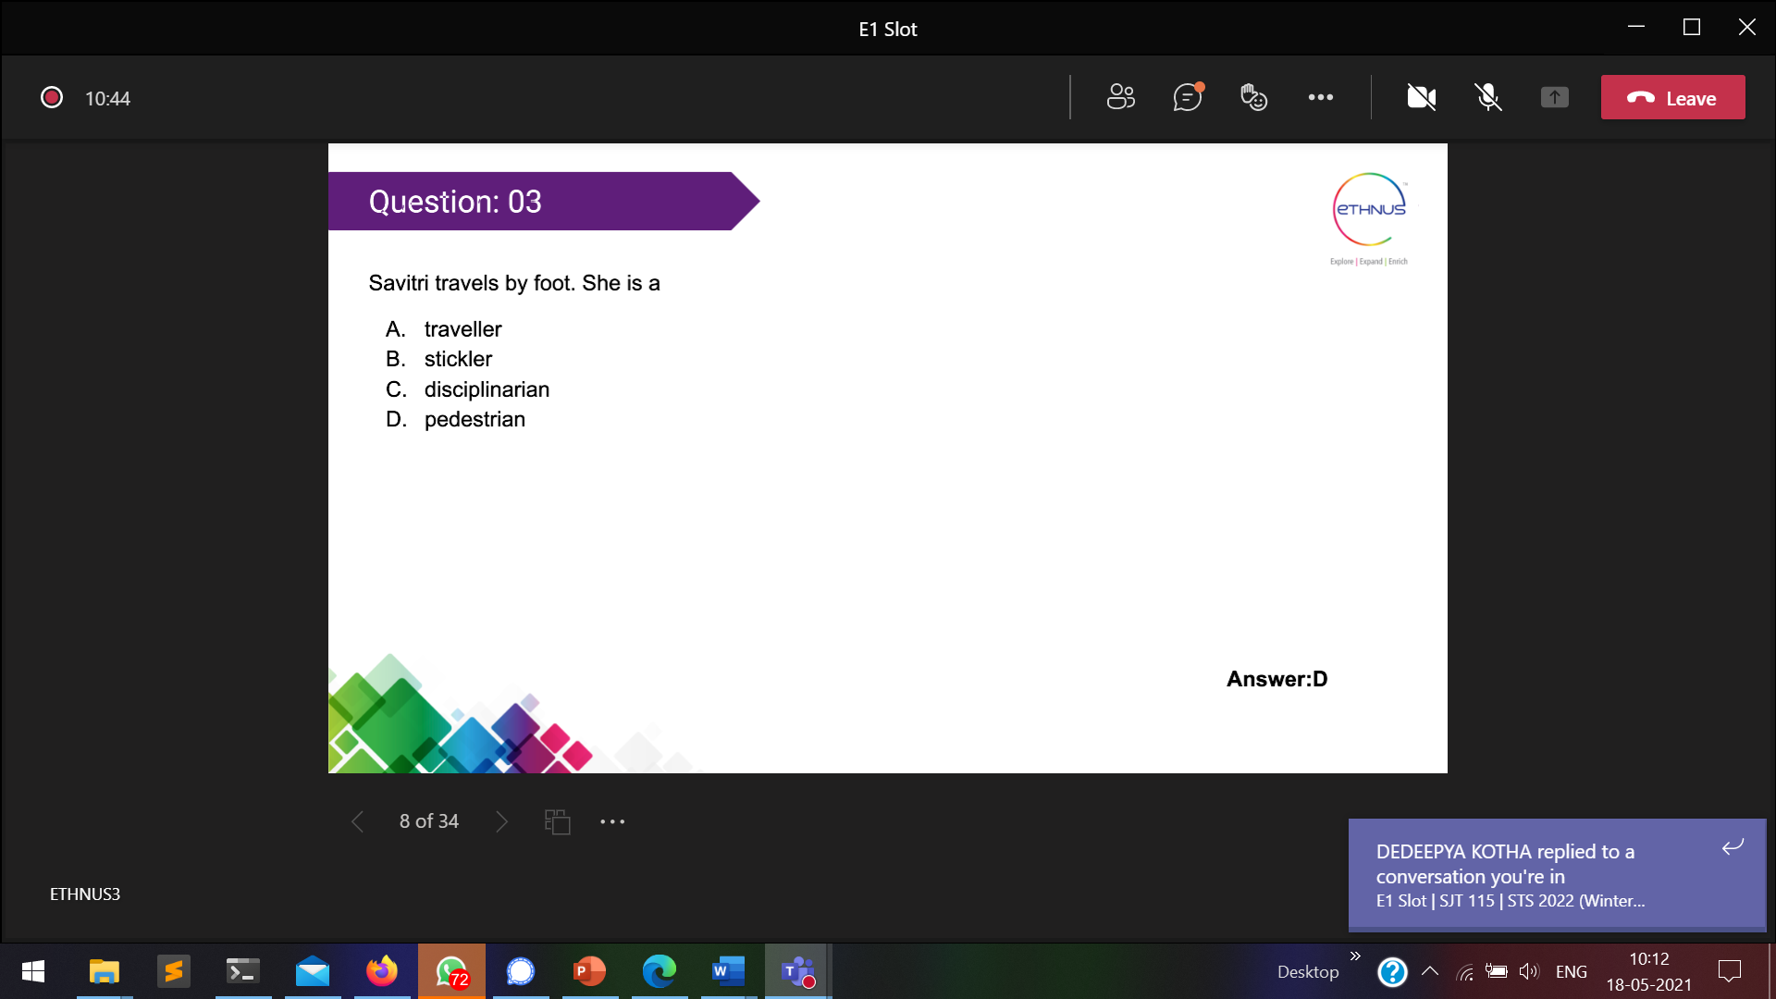

Stickler 🡪 a person who insists on a particular quality

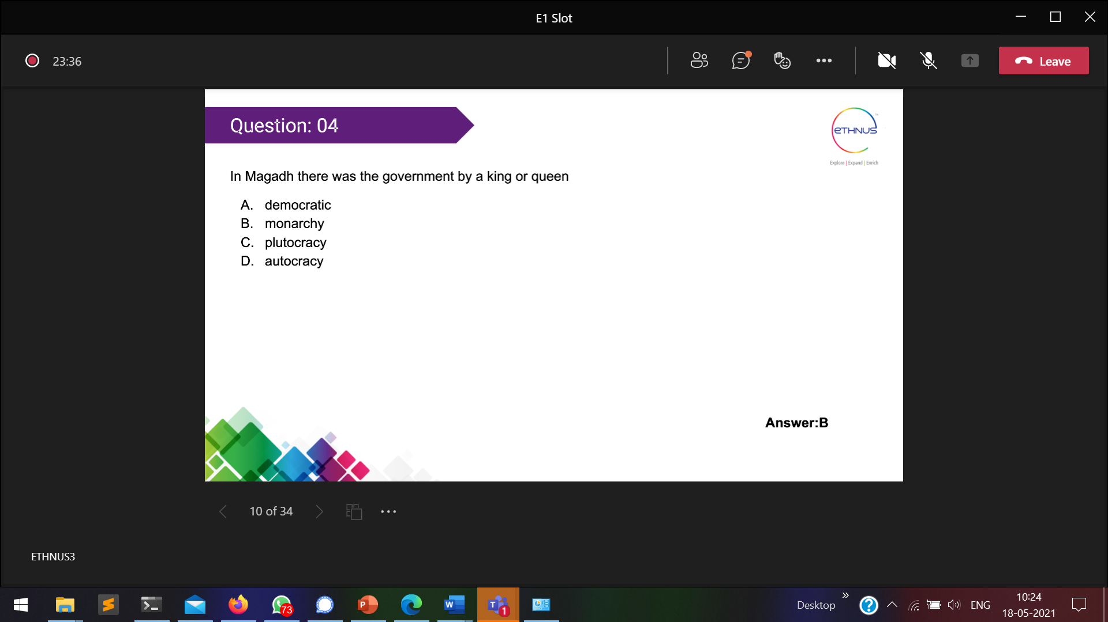

Monarchy 🡪

Monarchy 🡪 முடியாட்சி  
plutocracy 🡪   
autocracy 🡪 one person has complete power

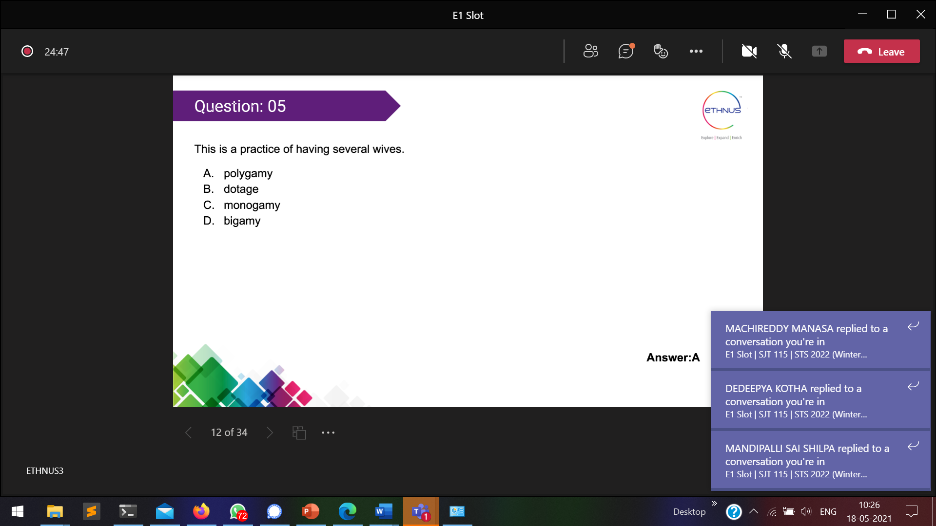

dotage 🡪 DECLINE OF MENTAL FACULTIES  
monogamy 🡪 only one  
bigamy 🡪 more than one

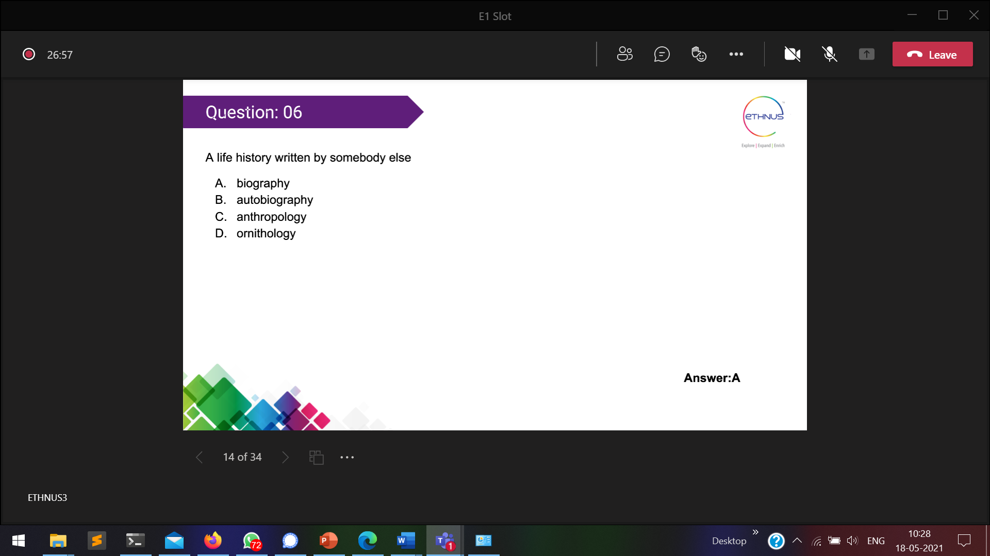

biography 🡪 written by other about me  
auto biography 🡪 written myself about me  
anthropology 🡪 kind of study of humans,customs,beliefs

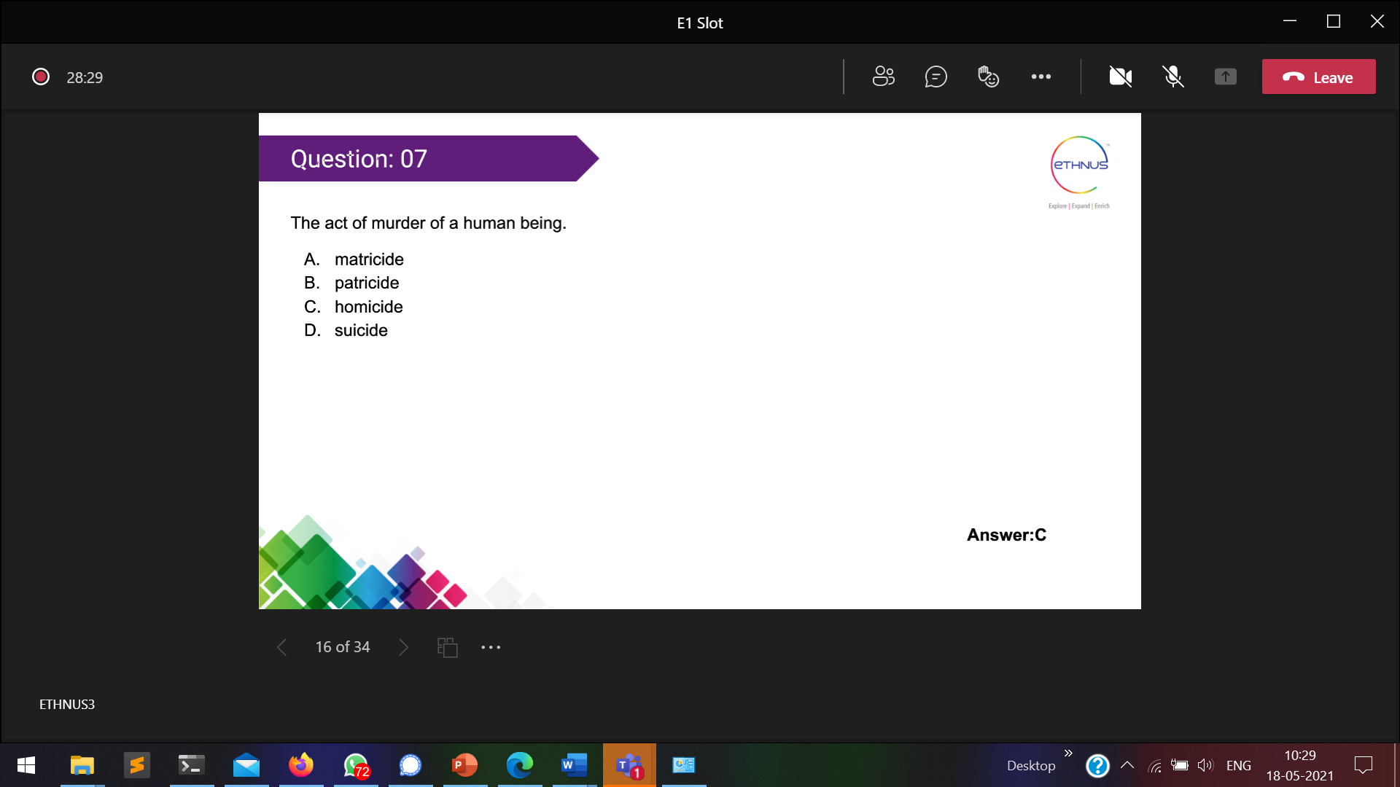

Matricide 🡪 killing ones mother

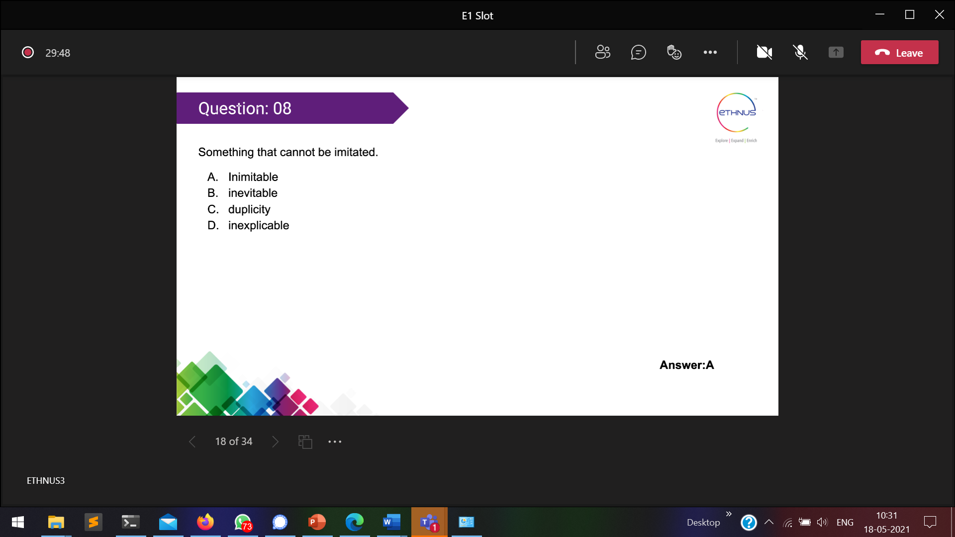

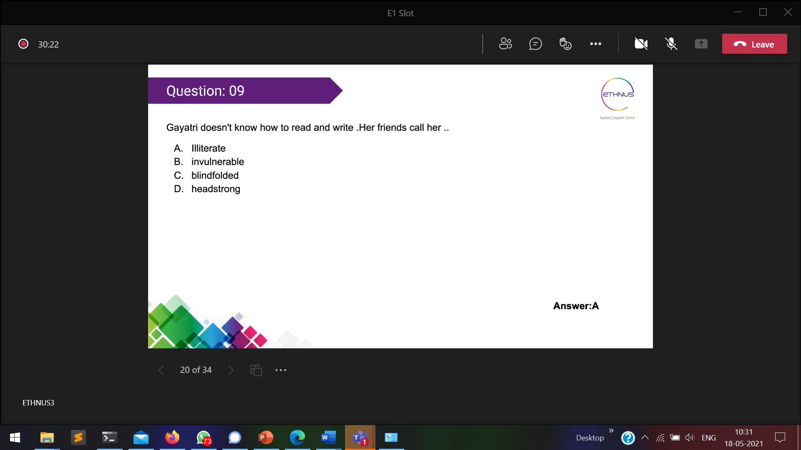

Invulnerable 🡪 harming some-one  
blindfolded 🡪   
headstrong

